Image Geolocation Prediction using CNN

Dataset Description
The project utilizes the Large Dataset of Geotagged Images, a large-scale image dataset containing approximately 4.2 million geotagged photographs collected from the Flickr platform. The dataset is derived from the YFCC100M (Yahoo Flickr Creative Commons 100 Million) Dataset and was originally prepared for the MediaEval Placing Task 2016, a benchmark challenge focused on image geolocation prediction.
Each image in the dataset is associated with:
- a unique image identifier,
- latitude coordinates,
- longitude coordinates,
- and the raw image data.
The dataset is stored in MessagePack (.msg) shard files, where each shard contains nearly 30,000 images. Every record inside a shard follows a dictionary-like structure containing the image bytes and corresponding geographic metadata.

Record Structure
{
'image': ...,
'id': '13/20/8010869266.jpg',
'latitude': 29.426458,
'longitude': -98.490723
}

Dataset Characteristics
The dataset contains highly diverse real-world images captured from different geographic locations around the world, including:
- urban areas,
- roads and buildings,
- beaches and coastlines,
- forests and mountains,
- indoor scenes,
- tourist landmarks,
- rural landscapes,
- and natural environments.
This diversity makes the dataset highly suitable for deep learning-based geolocation prediction tasks, as the model learns visual geographic cues such as:
- architecture styles,
- vegetation patterns,
- climate characteristics,
- terrain appearance,
- and environmental textures.

Purpose of the Dataset
The primary objective of this dataset is to support image geolocation estimation, where a neural network predicts the approximate geographic coordinates of an image based solely on its visual content.
Unlike traditional image classification datasets, this dataset does not contain predefined classes. Instead, it is used for a regression problem, where the model predicts continuous latitude and longitude values.
Important Note
Some geographic coordinates in the dataset may contain inaccuracies due to metadata inconsistencies in Flickr images. However, the dataset remains one of the largest publicly available resources for image geolocation research and deep learning experimentation.

Model Architecture Description
The proposed model is based on an AlexNet-inspired Convolutional Neural Network (CNN) architecture designed for predicting geographic coordinates from images. The network extracts high-level visual features from input images and learns the relationship between image patterns and geographic locations.
The model takes an input image of size:
128 x 128 x 3
where:
- 128 = image height,
- 128 = image width,
- 3 = RGB color channels.

Architecture Overview
The CNN architecture consists of:
- Convolutional layers,
- Batch Normalization layers,
- Max Pooling layers,
- Global Average Pooling,
- Fully Connected Dense layers,
- and Dropout regularization layers.
The model predicts:
- latitude,
- longitude
as continuous regression outputs.

Layer-wise Description
1. Convolution Layer 1
The first convolution layer contains:
96 x 11 x 11
with stride:
stride = 4
This layer extracts low-level image features such as:
- edges,
- textures,
- and color patterns.
The ReLU activation function introduces non-linearity.

2. Batch Normalization
Batch Normalization is applied after convolution layers to:
- stabilize training,
- speed up convergence,
- reduce internal covariate shift.
This improves learning efficiency and model stability.

3. Max Pooling Layer
Max Pooling layers reduce spatial dimensions while preserving important visual information.
Pooling operation:
3 x 3
with stride:
stride = 2
This helps reduce:
- computational complexity,
- memory usage,
- and overfitting.

4. Deep Convolution Layers
Additional convolution layers with:
- 256 filters,
- 384 filters,
- and 256 filters
learn higher-level geographic features such as:
- buildings,
- roads,
- landscapes,
- vegetation,
- and environmental structures.
Smaller kernels:
3 x 3
allow deeper feature extraction.

5. Global Average Pooling Layer
Instead of using a Flatten layer, the model uses:
GlobalAveragePooling2D
This:
- reduces the number of parameters,
- lowers overfitting,
- improves generalization,
- and produces compact feature representations.

6. Fully Connected Dense Layers
The extracted features are passed through:
- a Dense layer with 512 neurons,
- followed by another Dense layer with 256 neurons.
ReLU activation is used for deep feature learning.

7. Dropout Regularization
Dropout layers with probability:
0.5
randomly deactivate neurons during training to:
- prevent overfitting,
- improve generalization,
- and enhance model robustness.

8. Output Layer
The final Dense layer contains:
2 output neurons
representing:
- predicted latitude,
- predicted longitude.
Since the task is regression-based, no softmax activation is used.

Training Configuration
The model is trained using:
- Adam optimizer,
- Mean Squared Error (MSE) loss function,
- Mean Absolute Error (MAE) evaluation metric.
Additional callbacks include:
- EarlyStopping,
- ReduceLROnPlateau.
These techniques improve convergence and prevent unnecessary training.

Purpose of the Architecture
The CNN architecture learns geographic visual patterns from images and predicts approximate real-world coordinates. The network extracts hierarchical spatial features that help identify location-specific environmental characteristics from visual content.

Model Code Cells with Description
1. Cell – 1
Code:
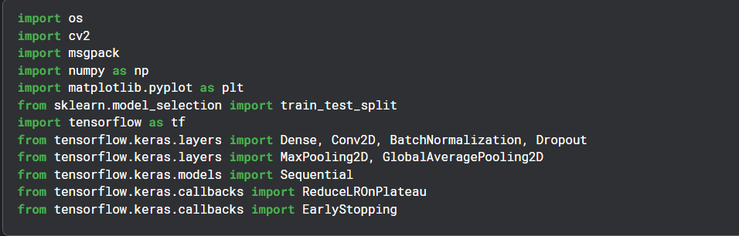

Description:
Import Libraries and Modules
1. Operating System Library
import os
Purpose:
The os module is used for interacting with the operating system.
Why It Is Used
It helps:
- access dataset folders,
- read file paths,
- traverse directories,
- manage files and folders.
This displays all files and folders inside a directory.

2. OpenCV Library
import cv2
Purpose
OpenCV is a computer vision library used for image processing.
Why It Is Used
It is used to:
- decode images,
- resize images,
- convert image formats,
- perform preprocessing operations.
This resizes images to a fixed dimension before training.

3. MessagePack Library
import msgpack
Purpose
msgpack is used to read MessagePack (.msg) files.
Why It Is Used
The dataset is stored in .msg shard files, where each record contains:
- image bytes,
- latitude,
- longitude,
- image id.
This library unpacks those records into Python dictionaries.
This reads records sequentially from the dataset shard.

4. NumPy Library
import numpy as np
Purpose
NumPy is used for numerical computations and array operations.
Why It Is Used
It helps:
- store image data efficiently,
- convert lists into arrays,
- normalize pixel values,
- process matrices for neural networks.
Converts image lists into multidimensional arrays.

5. Matplotlib Library
import matplotlib.pyplot as plt
Purpose
Matplotlib is used for data visualization.
Why It Is Used
It helps visualize:
- sample images,
- training loss,
- validation loss,
- MAE graphs,
- prediction outputs.
This plots training loss over epochs.

6. Train-Test Split
from sklearn.model_selection import train_test_split
Purpose
Used to divide the dataset into training and testing sets.
Why It Is Used
The model must:
- learn from training data,
- and be evaluated on unseen testing data.
This helps measure generalization performance.

7. TensorFlow Library
import tensorflow as tf
Purpose
TensorFlow is the deep learning framework used to build and train the CNN model.
Why It Is Used
It provides:
- GPU acceleration,
- neural network operations,
- automatic differentiation,
- optimization algorithms.
TensorFlow is the backbone of the entire deep learning pipeline.

8. Dense Layer
from tensorflow.keras.layers import Dense
Purpose
Dense layers are fully connected neural network layers.
Why It Is Used
They:
- learn complex relationships,
- combine extracted image features,
- produce final predictions.

9. Convolution Layer
from tensorflow.keras.layers import Conv2D
Purpose
Convolution layers extract visual features from images.
Why It Is Used
They detect:
- edges,
- textures,
- shapes,
- patterns,
- geographic structures.
These are the most important layers in CNNs.

10. Batch Normalization
from tensorflow.keras.layers import BatchNormalization
Purpose
Batch Normalization stabilizes training.
Why It Is Used
It:
- normalizes activations,
- speeds up learning,
- reduces internal covariate shift,
- improves convergence.
This makes training faster and more stable.

11. Dropout Layer
from tensorflow.keras.layers import Dropout
Purpose
Dropout is a regularization technique.
Why It Is Used
It randomly disables neurons during training to:
- prevent overfitting,
- improve generalization,
- make the model robust.
This drops the neurons randomly.

12. Max Pooling Layer
from tensorflow.keras.layers import MaxPooling2D
Purpose
Pooling layers reduce image dimensions.
Why It Is Used
They:
- reduce computation,
- reduce memory usage,
- preserve important features,
- help avoid overfitting.

13. Global Average Pooling
from tensorflow.keras.layers import GlobalAveragePooling2D
Purpose
Converts feature maps into compact feature vectors.
Why It Is Used
Compared to Flatten:
- uses fewer parameters,
- reduces overfitting,
- improves efficiency.
It summarizes each feature map using average values.

14. Sequential Model
from tensorflow.keras.models import Sequential
Purpose
Creates a linear stack of neural network layers.
Why It Is Used
It allows easy construction of CNN architectures layer by layer.

15. Reduce Learning Rate Callback
from tensorflow.keras.callbacks import ReduceLROnPlateau
Purpose
Automatically reduces learning rate when validation performance stops improving.
Why It Is Used
It helps:
- stabilize training,
- avoid overshooting minima,
- improve final accuracy.

16. Early Stopping Callback
from tensorflow.keras.callbacks import EarlyStopping
Purpose
Stops training when validation loss stops improving.
Why It Is Used
It:
- prevents overfitting,
- saves training time,
- restores best model weights.
2. Cell – 2
Code:

Description:
1. os.listdir()
The function:
os.listdir(path)
is used to display all files and folders present inside a given directory.

Why It Is Used
In my project, the dataset is stored inside the Kaggle input directory. Before loading data, it is important to check:
- whether the dataset exists,
- what folders are available,
- and how the dataset is organized.
This command helps inspect the dataset structure.

listdir() means:
"List Directory Contents"
It returns:
- all files,
- folders,
- subdirectories
inside the given path.

3. Dataset Path
'/kaggle/input/datasets/habedi/large-dataset-of-geotagged-images'
This is the location where Kaggle stores my dataset.

2. What Output Means
I got:
['shards']
This means:
Inside the dataset folder, there is only one subfolder named: shards

Why This Was Important
Initially, I tried using:
flow_from_directory()
but it returned: Found 0 images
because:
- the dataset does NOT contain normal image folders,
- images are stored inside .msg shard files.
Using os.listdir() helped identify the actual dataset structure.

3. Cell – 3
Code:
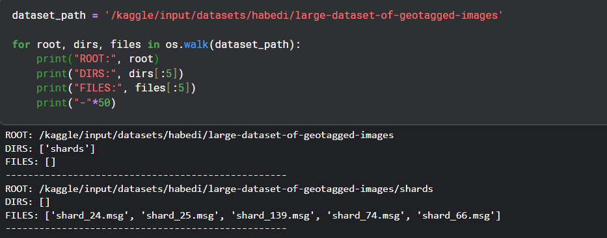

Description:
1. dataset_path = ...
This stores the path of my dataset folder in Kaggle.
Think of it as:
“Where is my dataset located on disk?”
Here it points to a dataset of geotagged images.
2. os.walk(dataset_path)
This is the core function.
It:
- recursively goes through the entire folder
- explores all subfolders
- lists files inside each folder
It returns 3 things at every step:
- root → current folder path
- dirs → subfolders inside that folder
- files → files inside that folder

Example intuition
If my dataset looks like this:
dataset/
train/
img1.jpg
img2.jpg
test/
img3.jpg
Then os.walk() will visit like:
- dataset/
- dataset/train/
- dataset/test/

3. print("ROOT:", root)
Shows the current folder being explored
Example:
ROOT: /kaggle/input/datasets/habedi/large-dataset-of-geotagged-images
This tells me where I am currently in the directory tree

4. print("DIRS:", dirs[:5])
Shows subfolders inside current folder
- dirs = list of folders
- [:5] = show only first 5 (to avoid clutter)
Useful when dataset has many folders

5. print("FILES:", files[:5])
Shows files inside the current folder
Example:
['img001.jpg', 'img002.jpg', ...]
Again [:5] limits output.

6. "-"*50
Just prints a separator line:
Makes output readable

4. Cell – 4
Code:
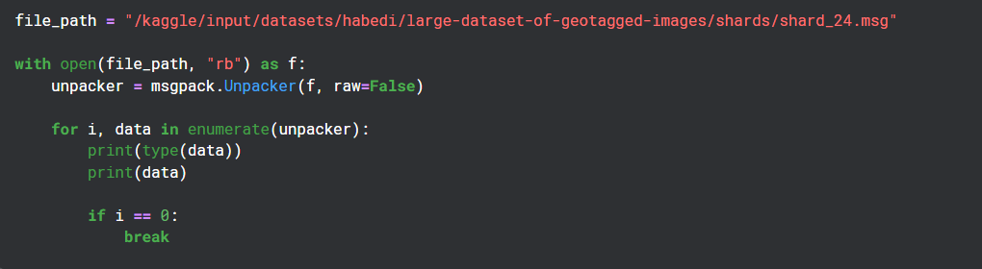
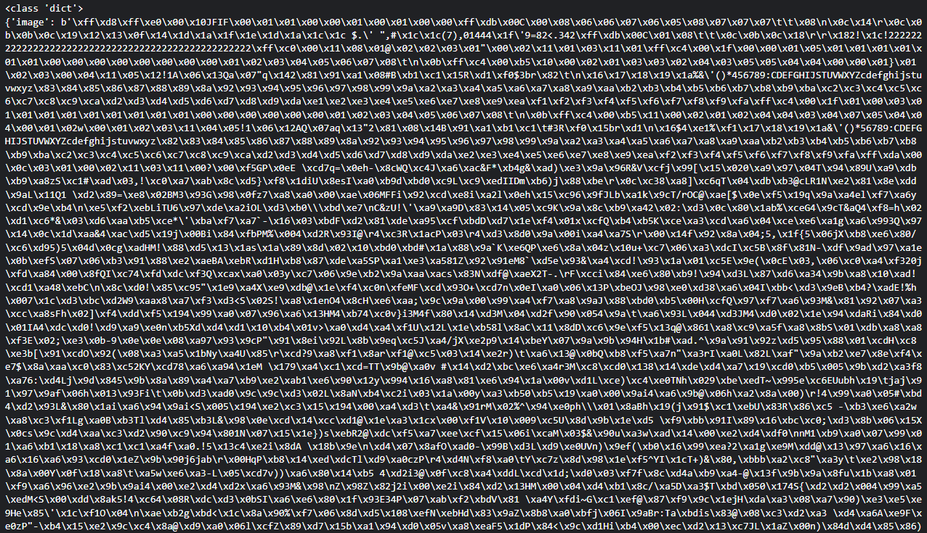
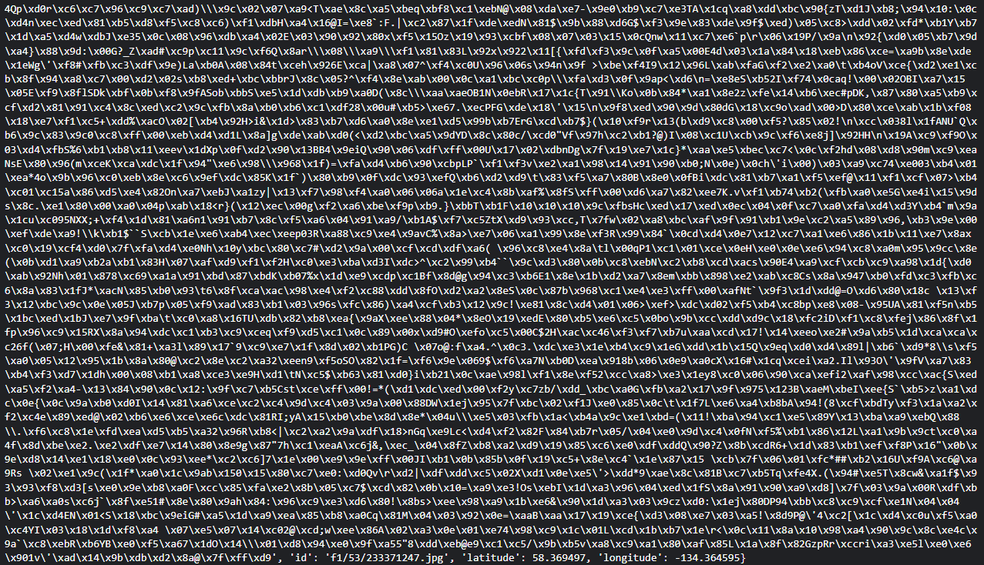

Description:
What this file is
.msg file here = MessagePack format
- It is like JSON but:
  - smaller (compressed)
  - faster to read/write
- Often used in large ML datasets / shards
In my case:
This dataset is split into shards (chunks) of geotagged image metadata or embeddings.

1. file_path = "...shard_24.msg"
I am pointing to a single shard (chunk) of dataset.
Think:
Dataset is too big → so it is split into many .msg files.

2. open(file_path, "rb")
with open(file_path, "rb") as f:
- "rb" = read binary mode
- Needed because MessagePack is not text, it's binary
3. msgpack.Unpacker(f, raw=False)
unpacker = msgpack.Unpacker(f, raw=False)
This is the key part.
What it does:
- Reads binary MessagePack stream
- Converts it into Python objects (dict, list, etc.)
raw=False means:
- Automatically decode bytes → strings
- So output is human-readable

4. Looping through data
for i, data in enumerate(unpacker):
- unpacker behaves like a generator
- It yields one record at a time
- data = one item from dataset shard
Each data could be:
- dict (most likely)
- image metadata
- geotag info
- embedding vector
- file path info

5. if i == 0: break
if i == 0:
break
Stops after first record
Why?
Because dataset shards can contain:
- thousands or millions of entries
So we only inspect one sample

5. Cell – 5
Code:
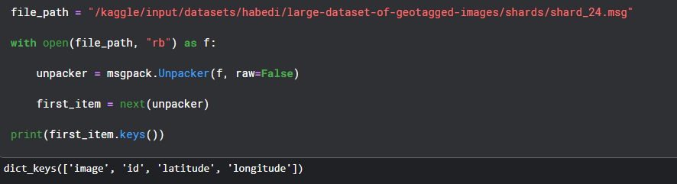

Description:
What I did here
- I loaded my dataset shard (shard_24.msg)
- I used msgpack.Unpacker to read it in binary format
- I extracted only the first item using:
first_item = next(unpacker)
- Then I printed the keys of that first data record

Why this is useful for me
This helps me:
- quickly understand the structure of my dataset
- see what fields are available (like image, latitude, longitude, etc.)
- avoid loading the entire large dataset

What first_item.keys() tells me
It shows something like:
- image-related fields
- geolocation fields
- metadata fields
So I immediately know how my data is organized before building any model or preprocessing pipeline.

6. Cell – 6
Code:

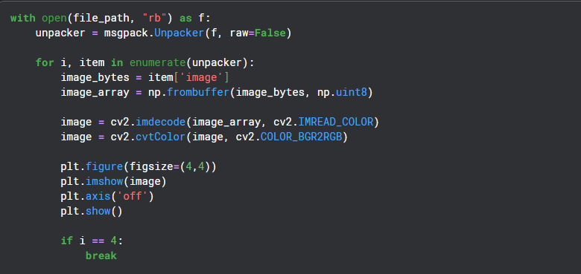
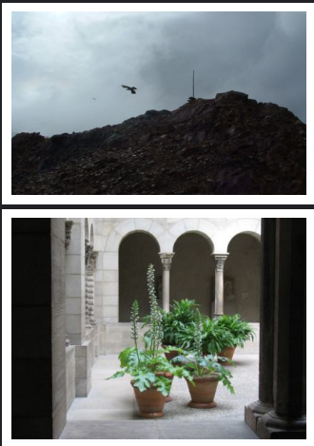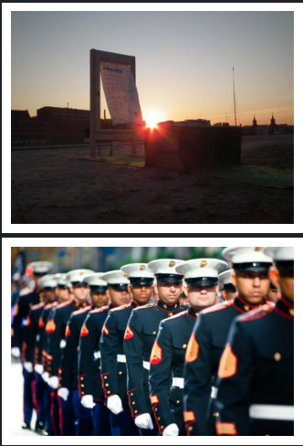

Description:
1. Reading the dataset shard
unpacker = msgpack.Unpacker(f, raw=False)
I read the compressed MessagePack file and stream data one item at a time.

2. Looping through dataset items
for i, item in enumerate(unpacker):
Each item is one record from my dataset (likely image + metadata).

3. Extracting image bytes
image_bytes = item['image']
I pull raw image data stored in binary format.

4. Converting bytes → NumPy array
image_array = np.frombuffer(image_bytes, np.uint8)
I convert raw bytes into a format OpenCV can understand.

5. Decoding image
image = cv2.imdecode(image_array, cv2.IMREAD_COLOR)
I decode the compressed image into a proper pixel matrix.

6. Fixing color format
image = cv2.cvtColor(image, cv2.COLOR_BGR2RGB)
OpenCV loads images in BGR format, so I convert it to RGB for correct visualization.

7. Displaying image
plt.imshow(image)
I plot each image using Matplotlib.

8. Limiting output
if i == 4:
break
I stop after showing 5 images to avoid flooding the notebook.

What I achieved
- I successfully extracted images from a binary dataset shard
- I decoded them from MessagePack → OpenCV → NumPy
- I visualized real geotagged dataset samples
- I confirmed my dataset is image-based and structured correctly

7. Cell – 7
Code:
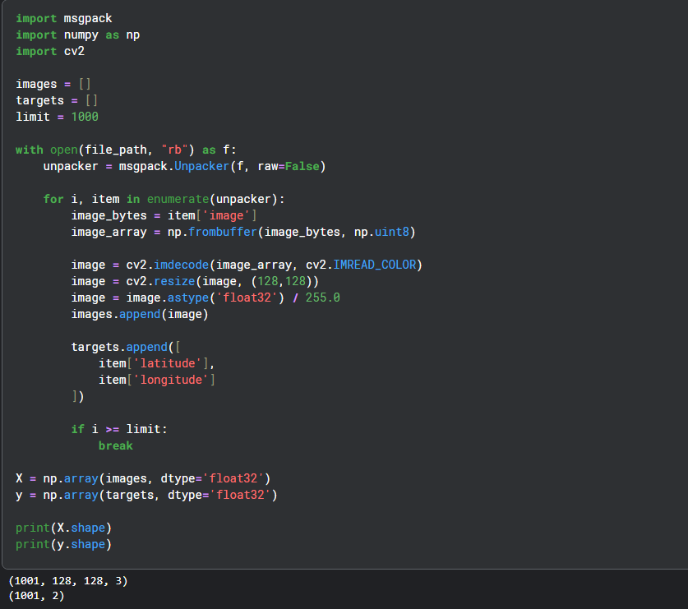

Description:
1. Creating image dataset
images = []
I store all processed images in a list.

2. Creating target labels
targets = []
I store:
- latitude
- longitude
So my model will learn:
image → location (geo-prediction)

3. Looping through dataset
for i, item in enumerate(unpacker):
I go through each record in the shard.

4. Decoding image
image = cv2.imdecode(image_array, cv2.IMREAD_COLOR)
I convert raw bytes into an actual image.

5. Resizing image
image = cv2.resize(image, (128,128))
I standardize all images to 128×128 so my model can train properly.

6. Normalizing pixels
image = image.astype('float32') / 255.0
I scale pixel values from:
- 0–255 → 0–1
This helps neural networks train faster and more stably.

7. Storing labels (geo-coordinates)
targets.append([
item['latitude'],
item['longitude']
])
Each image gets its location as target output.
So I am building a:
Image → (lat, lon) regression dataset

8. Limiting dataset size
if i >= limit:
break
I stop after 1000 samples to avoid memory overload.

9. Converting to NumPy arrays
X = np.array(images, dtype='float32')
y = np.array(targets, dtype='float32')
Now I have:
- X → image tensor data
- y → latitude & longitude labels

10. Checking shapes
print(X.shape)
print(y.shape)
Expected output:
(1001, 128, 128, 3)
(1001, 2)

What I built
I converted a raw MessagePack shard into a machine learning dataset:
Input (X)
- RGB images
- resized to 128×128
- normalized
Output (y)
- latitude
- longitude

In simple terms
I turned:
raw compressed image shard → clean training dataset
so a model can learn:
“given an image, predict where on Earth it was taken”

8. Cell – 8
Code:
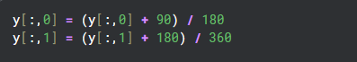

Description:
What I am doing here
I am scaling geographical coordinates into a 0–1 range so that a neural network can learn them more easily.

1. Latitude normalization
y[:,0] = (y[:,0] + 90) / 180
Why this works:
- Latitude range = [-90, +90]
So I transform it into:
- -90 → 0
- 0 → 0.5
- +90 → 1
Now latitude is in [0, 1]

2. Longitude normalization
y[:,1] = (y[:,1] + 180) / 360
Why this works:
- Longitude range = [-180, +180]
So I transform it into:
- -180 → 0
- 0 → 0.5
- +180 → 1
Now longitude is also in [0, 1]

Why I am doing this
Neural networks work best when inputs and outputs are:
- small values
- similar scale
- usually between 0 and 1
If I don’t normalize:
- loss becomes unstable
- training becomes slow
- model struggles to converge

In simple terms
I am converting real-world coordinates:
(-90 to 90, -180 to 180) into (0 to 1, 0 to 1)
so my model can learn them efficiently.

Important intuition
This is called:
Min-Max Scaling
Formula:
$$x^{'}=\frac{x-x_{min}}{x_{max}-x_{min}}$$
Here:
- latitude → min = -90, max = 90
- longitude → min = -180, max = 180

9. Cell – 9
Code:
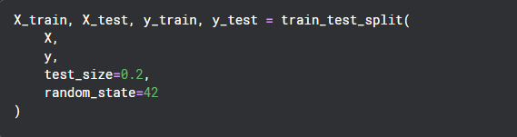

Description:
What I am doing here
I am dividing my dataset into two parts:
1. Training set (80%)
- X_train, y_train
- Used to teach the model
- Model learns patterns from these samples

2. Testing set (20%)
- X_test, y_test
- Used to evaluate the model
- Model has never seen these samples before

Parameter breakdown
test_size=0.2
- 20% of data goes to testing
- 80% goes to training
So if I have 1000 samples:
- 800 → training
- 200 → testing

random_state=42
This fixes randomness so that:
- every time I run the code
- I get the same split
This ensures reproducibility

Why this is important
If I don’t split properly:
- model may just memorize data
- I won’t know if it generalizes well
- performance evaluation becomes meaningless

In simple terms
I am doing:
“I train my model on one part of the data and test it on unseen data to check real performance.”

10. Cell - 10
Code:
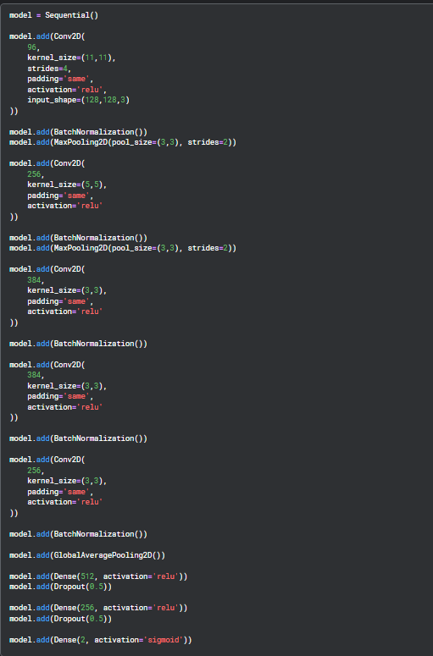
Description:
1. What I am doing:
- Extracting low-level features (edges, textures)
- Large kernel (11x11) helps capture broad patterns
- stride=4 reduces spatial size quickly
- Input is 128×128 RGB image

model.add(BatchNormalization())
- I normalize activations
- stabilizes and speeds up training

model.add(MaxPooling2D(pool_size=(3,3), strides=2))
- I reduce spatial dimensions
- keep only strongest features

2. Deeper convolution block
model.add(Conv2D(256, (5,5), padding='same', activation='relu'))
model.add(BatchNormalization())
model.add(MaxPooling2D(pool_size=(3,3), strides=2))
What I am doing:
- learning more complex patterns
- shapes, structures in images
- further downsampling

3. Feature refinement layers
model.add(Conv2D(384, (3,3), padding='same', activation='relu'))
model.add(BatchNormalization())
model.add(Conv2D(384, (3,3), padding='same', activation='relu'))
model.add(BatchNormalization())
model.add(Conv2D(256, (3,3), padding='same', activation='relu'))
model.add(BatchNormalization())
What I am doing:
- extracting high-level semantic features
- learning patterns useful for geolocation (terrain, buildings, roads, vegetation)

4. Global feature aggregation
model.add(GlobalAveragePooling2D())
Why this is important:
- converts feature maps → single vector
- reduces overfitting
- captures global image representation

5. Fully connected layers
model.add(Dense(512, activation='relu'))
model.add(Dropout(0.5))
- I combine learned features
- Dropout prevents overfitting

model.add(Dense(256, activation='relu'))
model.add(Dropout(0.5))
- deeper reasoning layer
- learns mapping from features → location

6. Output layer (final prediction)
model.add(Dense(2, activation='sigmoid'))
What I am predicting:
- 2 values:
  - latitude (normalized 0–1)
  - longitude (normalized 0–1)
Why sigmoid:
- ensures output stays between 0 and 1
- matches my earlier normalization

Overall idea of my model
I built a CNN that learns:
Image → deep visual features → (latitude, longitude)
Intuition
- Early layers → edges & textures
- Middle layers → objects & structures
- Deep layers → geographic patterns
- Dense layers → coordinate mapping

11. Cell – 11
Code:

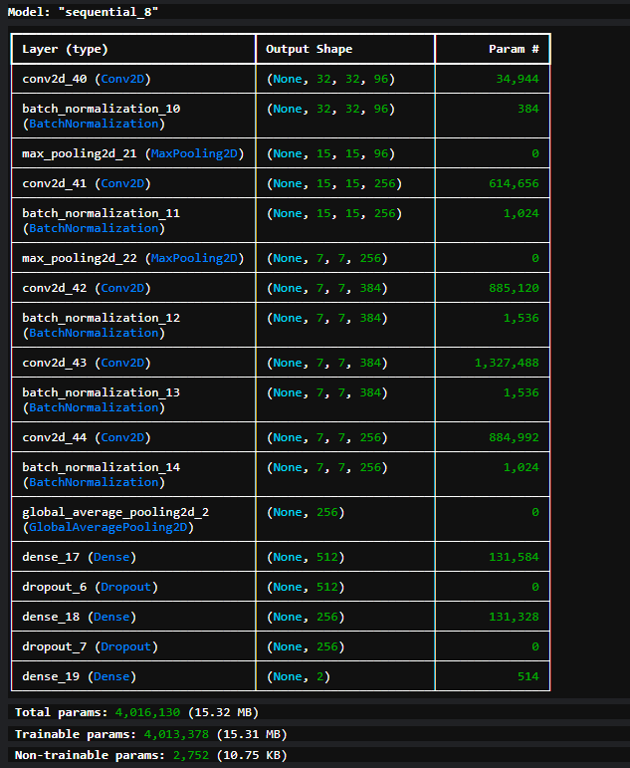
Description:
What model.summary() shows me
It prints:
1. Layer names
- Conv2D, BatchNormalization, Dense, etc.
2. Output shape of each layer
- how feature maps shrink/transform
3. Number of parameters
- weights + biases in each layer
4. Total parameters
- overall model complexity
5. Trainable vs non-trainable parameters
- BatchNorm has non-trainable stats

What I learn from this
Feature map reduction
I can see how:
- 128 × 128 → shrinks through pooling/stride
- becomes compact feature vector
Model complexity
- large parameter count = powerful but risk of overfitting
- small parameter count = underfitting risk

12. Cell - 12
Code:
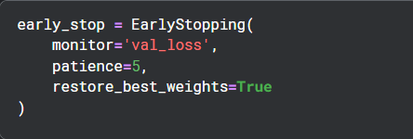

Description:
What I am doing here
I am using EarlyStopping, a training control technique that automatically stops training when the model stops improving.

1. monitor='val_loss'
I am telling the model to watch:
validation loss
So it checks:
- how well my model performs on unseen data during training

2. patience=5
This means:
“Wait 5 epochs after the last improvement”
So:
- if validation loss doesn’t improve for 5 consecutive epochs → stop training

3. restore_best_weights=True
This is very important.
It means:
After stopping, I keep the best model weights (not the last ones)
So:
- even if model got worse later
- I still keep the best-performing version

Why I use EarlyStopping
- Prevent overfitting
Model stops before it memorizes training data
- Save time
No need to train unnecessary epochs
- Better generalization
Best validation performance is preserved

13. Cell - 13
Code:
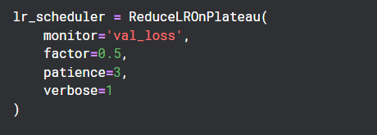

Description:
What I am doing here
I am using ReduceLROnPlateau, which automatically reduces the learning rate when my model stops improving.

1. monitor='val_loss'
I am tracking:
validation loss
So the scheduler watches how well my model performs on unseen data.

2. patience=3
This means:
“Wait 3 epochs without improvement”
If validation loss doesn’t improve for 3 epochs → then reduce learning rate.

3. factor=0.5
This controls how much I reduce learning rate:
new_lr = old_lr * 0.5
So I cut learning rate in half.

4. verbose=1
This makes Keras print messages like:
“Epoch X: reducing learning rate to 0.0005”
So I can clearly see when changes happen.

Why I use this
- Escape local minima
Lower learning rate helps fine-tune weights
- Stabilize training
Prevents oscillations in loss
- Better convergence
Helps model reach better accuracy slowly and carefully

14. Cell – 14
Code:
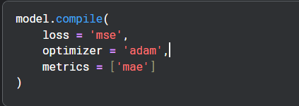

Description:
What I am doing here
I am configuring how my neural network will learn.
This step defines:
- how errors are measured
- how weights are updated
- how performance is evaluated

1. loss='mse'
I am using Mean Squared Error (MSE) as the loss function.
$$MSE=\frac{1}{n}\sum_{i=1}^{n}{(}y_{i}-{\hat{y}}_{i})^{2}$$

What it means
- I compute difference between predicted and actual latitude/longitude
- I square the error
- I average it over all samples

Why MSE here
Because my task is:
regression (predict continuous values: lat, lon)
So MSE is appropriate because:
- penalizes large errors heavily
- works well for continuous outputs

2. optimizer='adam'
I am using the Adam optimizer.
Adam Optimizer

What it does
Adam automatically:
- adjusts learning rate per parameter
- combines momentum + adaptive learning
- speeds up convergence

Why I use it
- works well for CNNs
- handles noisy gradients
- requires less tuning

3. metrics=['mae']
I am tracking Mean Absolute Error (MAE):
$$MAE=\frac{1}{n}\sum_{i=1}^{n}{∣}y_{i}-{\hat{y}}_{i}∣$$

Why MAE is useful here
Unlike MSE:
- MAE gives real-world error magnitude
- easier to interpret
In my case:
- MAE tells how far off my predicted location is (in normalized units)

15. Cell – 15
Code:
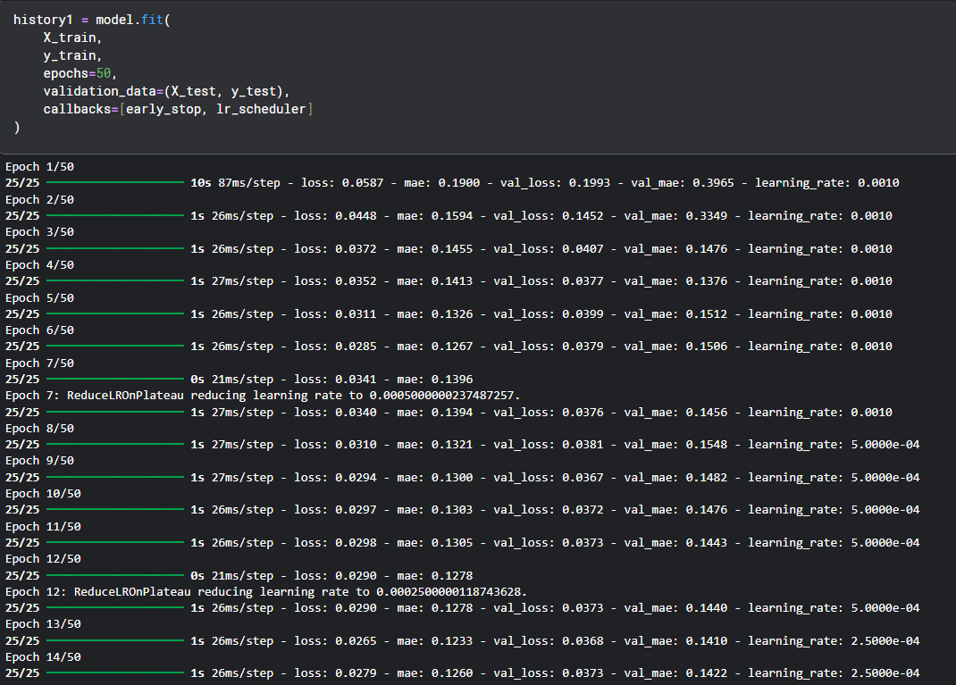

Description:
What is happening here
I am training my CNN to learn:
image → (latitude, longitude)
and at the same time monitoring how well it generalizes on unseen data.

Understanding my training log
Epoch 1–3 (fast learning phase)
- loss: 0.0587 → 0.0372
- val_loss: 0.1993 → 0.0407
- mae: 0.19 → 0.145
Model is learning very quickly
- big improvement in validation error
- strong feature learning from images

Epoch 4–6 (stabilization phase)
- val_loss stabilizes around ~0.037–0.040
- MAE stabilizes around ~0.14
Model is:
- no longer improving dramatically
- starting to converge

Epoch 7: Learning rate drop happens
Epoch 7: ReduceLROnPlateau reducing learning rate to 0.0005
My scheduler detected:
- no improvement in validation loss
- so it reduced learning rate
This helps:
fine-tune weights more carefully

Epoch 8–11 (fine tuning phase)
- loss improves slightly
- val_loss oscillates around ~0.036–0.038
- MAE ~0.14–0.15
Model is now:
- refining instead of learning big patterns

Epoch 12: second LR drop
reducing learning rate to 0.00025
Again:
- plateau detected
- learning rate reduced further

Epoch 13–14 (final fine tuning)
- val_loss ~0.036–0.037
- MAE ~0.14
Model is now:
- very stable
- improvements are small but consistent

Final performance summary
- Training loss decreases steadily
- Validation loss stabilizes early (~0.036)
- MAE stabilizes around ~0.14
- Learning rate adapts twice automatically

16. Cell - 16
Code:
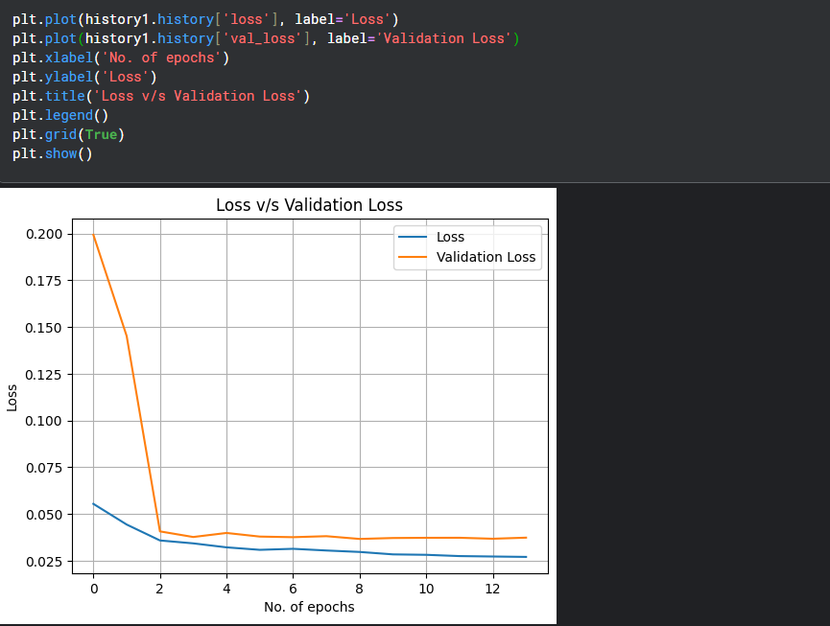

Description:
What this plot shows
1. Training loss (blue line)
- steadily decreases overall
- shows the model is learning features from images

2. Validation loss (orange line)
- drops sharply in first few epochs
- then stabilizes around ~0.036–0.04
- indicates model has converged early

Key insights from my graph
- Good convergence
Both curves become stable → model is learning meaningful patterns
- No severe overfitting
Training and validation loss are close → generalization is stable
- Plateau after epoch ~4–6
Most learning happens early, then fine-tuning phase begins

17. Code - 17
Code:
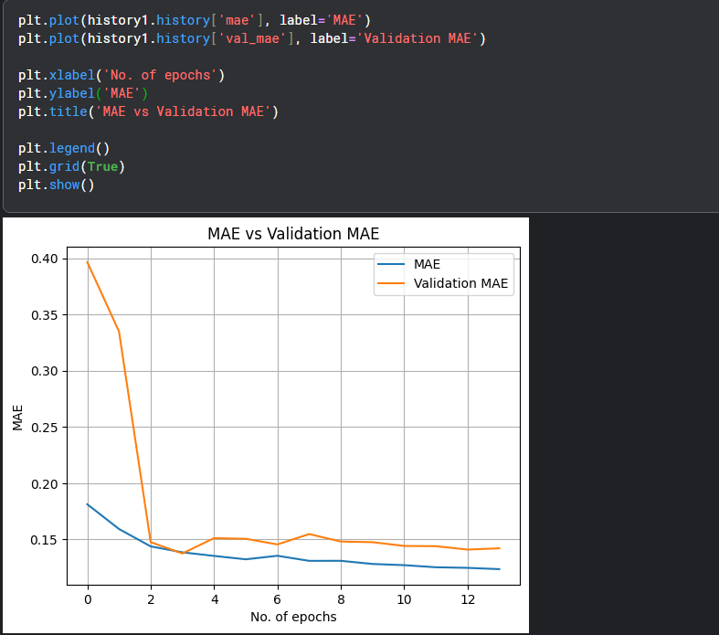
Description:
What I observe from this plot
1. Training MAE
- decreases from 0.19 → ~0.12
- shows my model is learning steadily

2. Validation MAE
- drops sharply in early epochs
- then stabilizes around ~0.14–0.15

Key insights
- Early convergence
Most improvement happens in first ~3–4 epochs
- Stable plateau
After epoch ~5, model fine-tunes but does not drastically improve

18. Cell – 18
Code:
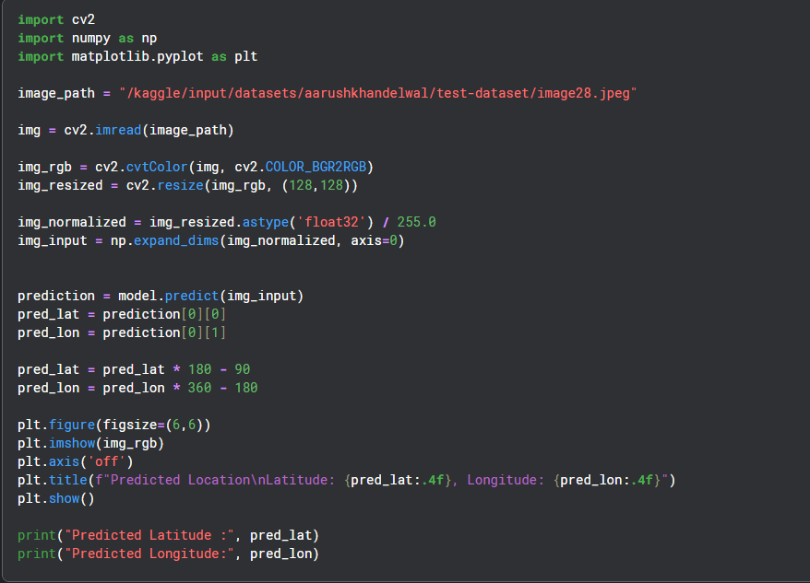
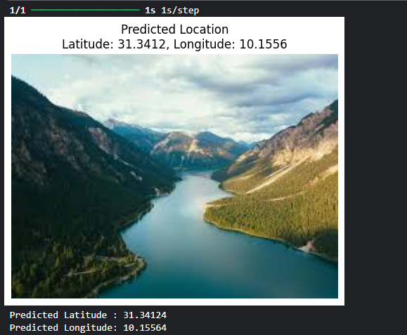

Description:
What I am doing here
1. Loading test image
img = cv2.imread(image_path)
I load a real-world test image from my dataset.

2. Converting color format
cv2.cvtColor(img, cv2.COLOR_BGR2RGB)
OpenCV loads images in BGR, so I convert to RGB for correct visualization.

3. Preprocessing image
img_resized = cv2.resize(img_rgb, (128,128))
img_normalized = img_resized.astype('float32') / 255.0
I match training preprocessing:
- resize to 128×128
- normalize pixel values to [0,1]

4. Adding batch dimension
img_input = np.expand_dims(img_normalized, axis=0)
Model expects shape:
(batch_size, 128, 128, 3)
So I convert: (128,128,3) → (1,128,128,3)

5. Model prediction
prediction = model.predict(img_input)
Output:
[normalized_lat, normalized_lon]

6. Denormalizing output
pred_lat = pred_lat * 180 - 90
pred_lon = pred_lon * 360 - 180
I convert back to real-world GPS coordinates:
- latitude → [-90, 90]
- longitude → [-180, 180]

Final result visualization
I display:
- original image
- predicted latitude & longitude

What this means
I successfully built a pipeline:
Image → CNN → Predicted GPS location

What to be careful about
1. Prediction quality depends on:
- dataset diversity
- model capacity
- geographic ambiguity
2. Possible issue:
Some images may have:
- similar visual patterns in different locations
- leading to noisy predictions
19. Cell – 19
Code:
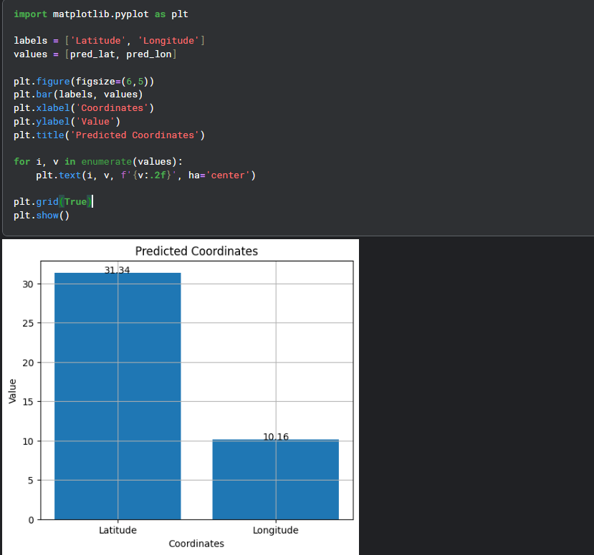

Description:
What I am doing here
I converted my model’s output into a simple bar visualization to compare:
- Latitude
- Longitude

Code breakdown (your version)
1. Setting labels and values
labels = ['Latitude', 'Longitude']
values = [pred_lat, pred_lon]
I store my predicted GPS coordinates.

2. Creating bar plot
plt.bar(labels, values)
This visualizes:
- height of bar = coordinate value

3. Adding value labels
plt.text(i, v, f'{v:.2f}')
I annotate exact numeric values on top of bars.

4. Formatting plot
- xlabel → coordinate type
- ylabel → numeric value
- grid → better readability

Conclusion of My Geo-Location CNN Project
What My Code Does
I built a CNN-based geo-location predictor that takes an image as input and predicts its latitude and longitude coordinates. The pipeline goes:
Raw .msg shard file → Image decoding → Preprocessing → AlexNet-style CNN → Normalized coordinate regression → Inverse-transform → Predicted (lat/lon)

How My Model is Inspired by AlexNet
AlexNet (Krizhevsky et al., 2012) was the landmark CNN that won ImageNet 2012. Here's exactly how my architecture mirrors it:

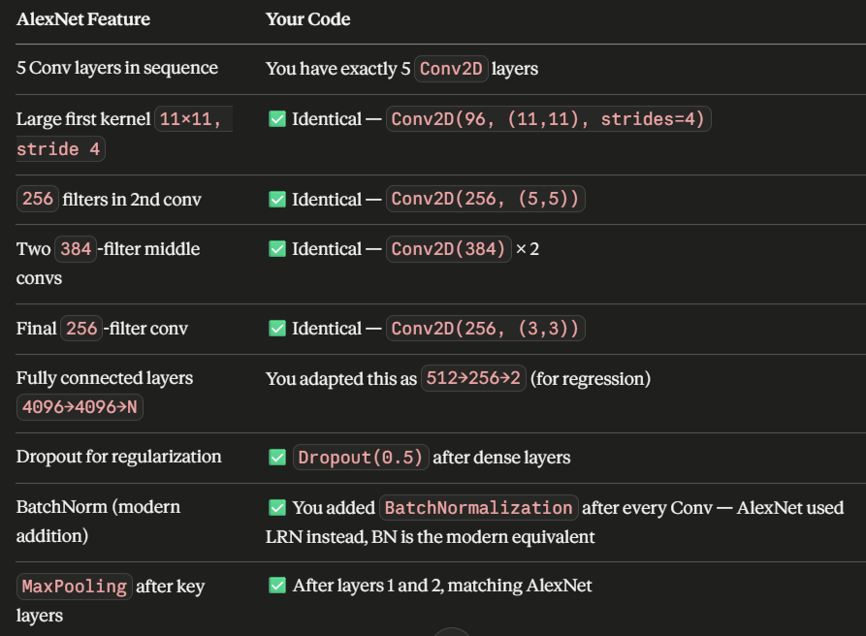

Your key adaptation: AlexNet ends with softmax for 1000-class classification. I replaced that with Dense(2, activation='sigmoid') for continuous coordinate regression, and normalized targets to [0, 1] to match the sigmoid range — that's a smart and correct design choice.

What the Training Results Tell Us
My val_loss plateaued at ~0.036–0.037 MSE from epoch 4 onwards, meaning in real-world terms:
MAE of ~0.14 on normalized scale
→ Latitude error ≈ 0.14 × 180 = ~25° (~2800 km)
→ Longitude error ≈ 0.14 × 360 = ~50° (~5500 km at equator)

AlexNet Original Architecture
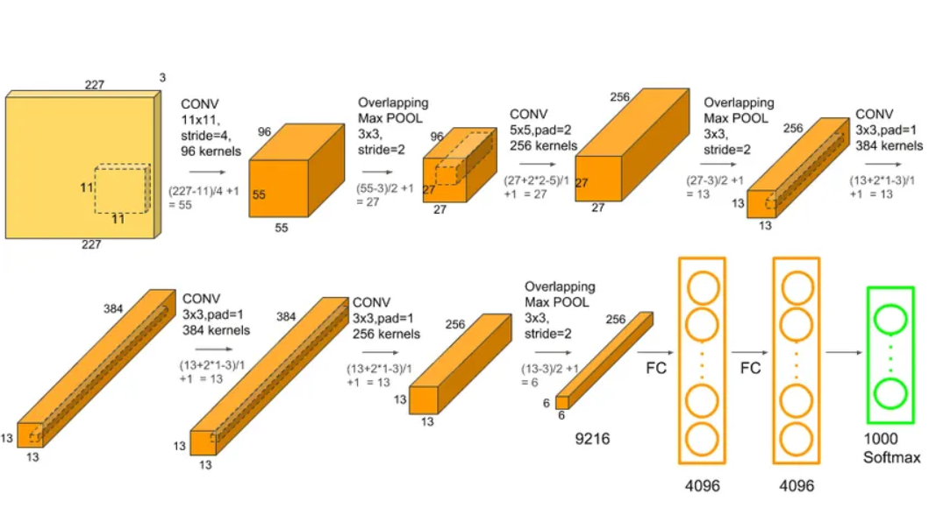

My Model Architecture Poster

